Welcome to the **HCAN** **Board Portal!**  This portal will contain meeting agendas & minutes as well as the financial statements.  You can access this by going to the website [www.healthcareaccessnow.org](http://www.healthcareaccessnow.org) and scrolling to the bottom- you will see the link on the bottom corner:

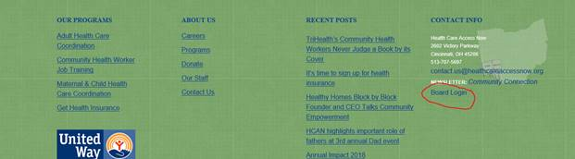

OR you can go directly to Link: <https://healthcareaccessnow.org/board-login/>

The password is: HCANboard2019!